**Name: JULIEANNE DENISE DENISE S. BALAHADIA BSEMC-DA**

1. Display all columns from tbl_employees.

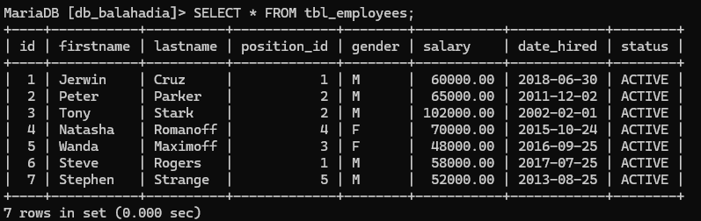

1. Display only the firstname and lastname of all employees.

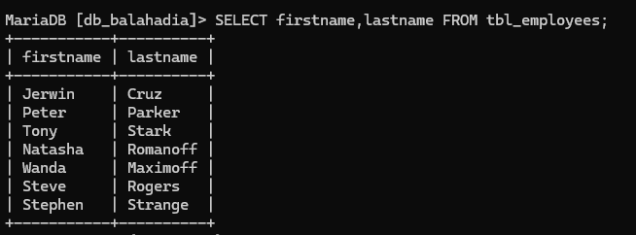

1. Show firstname, lastname, and salary of all employees.

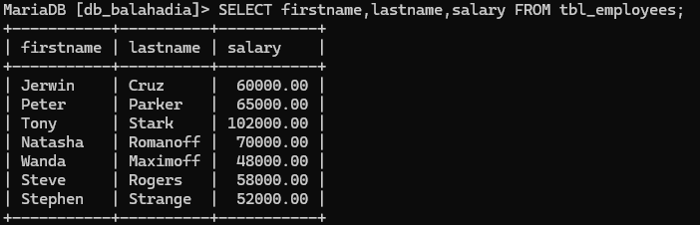

1. Find all employees whose firstname starts with **'S'**.

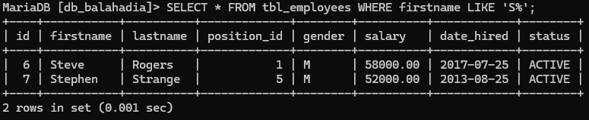

1. Find all employees whose lastname ends with **'off'**.

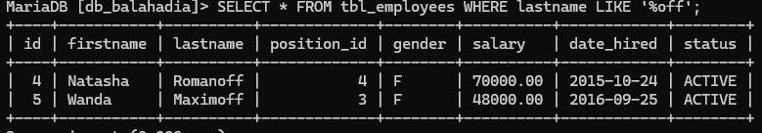

1. Find employees with firstname containing **'an'**.
2. Find employees whose firstname second letter is **'e'**.
3. Find employees whose lastname starts with **'R'**.
4. Show distinct position_id values.
5. Show distinct gender values from the table.
6. Display all employees with a salary greater than **60,000**.
7. Display all employees who were hired before **2015-01-01**.
8. Display employees with gender = 'F'.
9. Show employees whose status is ACTIVE.
10. Display employees whose salary is between **50,000** and **70,000**.
11. Display employees sorted by firstname in ascending order.
12. Display employees sorted by salary in descending order.
13. Show employees sorted by date_hired (oldest first).
14. Count how many employees are in each position_id.
15. Count how many employees are grouped by gender.
16. Find the total salary per position_id.
17. Show position_id groups having more than **1 employee**.
18. Show gender groups where the average salary is above **60,000**.
19. Show only the **first 3 employees** from the table.
20. Show **3 employees starting from the 3rd record** in the table.